# Geneva, DD.MM.YYYY

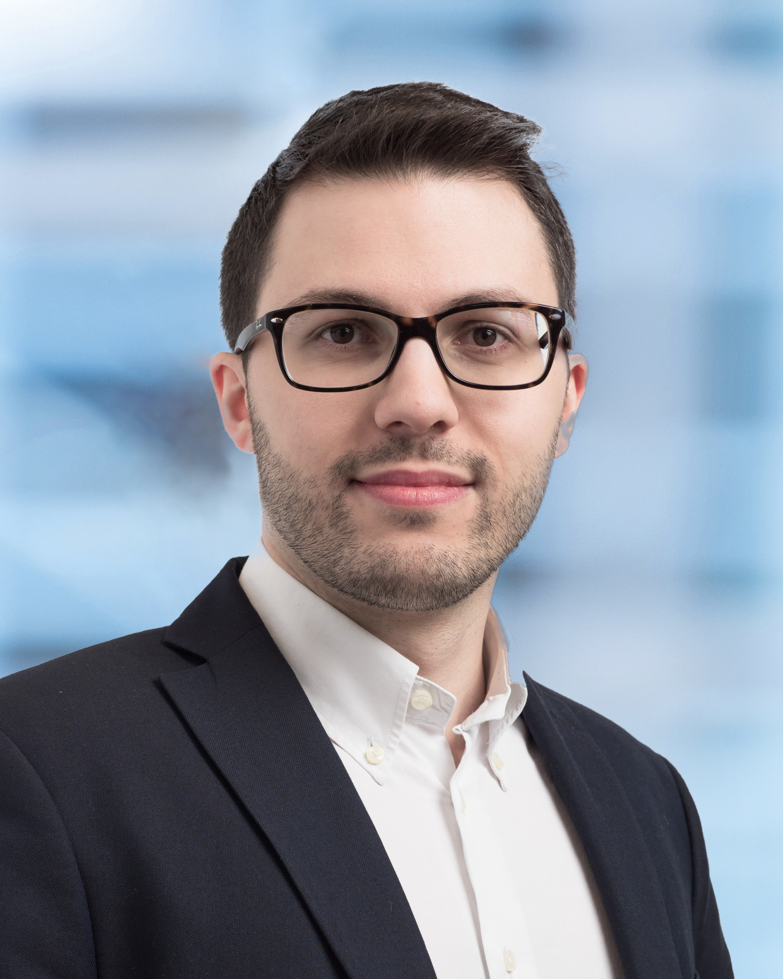

## Information to the Foundation Board

## SFI PhD Graduation Announcement

Andrea Bergesio

is currently completing the SFI PhD Program in Finance

at the University of Zürich

with a thesis on

“The role of frictional costs in insurance demand and valuation of insurance liabilities”

under the supervision of

Professor Cosimo-Andrea Munari, SFI-Fakultätsmitglied

(second supervior: Professor Pablo Koch-Medina)

Andrea Bergesio’s research over the past 5 years has covered topics in insurance economic valuation and corporate demand for insurance with market imperfections.

Given his knowledge of insurance economic valuation and financial regulation, Andrea Bergesio is interested in a position in the insurance and banking industry or as quantitative analyst.

* Education
* 2016-2022(expected) Swiss Finance Institute and University of Zürich, Switzerland.
* 2013-2016 M.sc. in Finance and Risk Management, Università degli Studi di Firenze,

Italy.

* 2014-2015 MSc in Money and Finance (Erasmus Program), Goethe Universität,

Germany.

* 2010-2013 B.sc. in Economics, Università degli Studi di Firenze, Italy.
* Work Experience
* 2019-2022 Teaching assistant – Microeconomics of Insurance, University of Zürich,

Switzerland.

* 2021-2022 Teaching assistant – Capital Adequacy and Risk Measures, University of Zürich, Switzerland.
* 2015-2016 Consultant, KMPG Advisory S.p.A., Italy.
* Languages (professional skill level)
* English
* Italian
* Contact
* andrea.bergesio@bf.uzh.ch
* https://www.linkedin.com/in/andrea-bergesio-ba0911115/
* +41 79 409 58 64
* 01.10.2022
* Permit B / Italian